St. Wilfrid’s C.E. Primary School
S.E.N.D Information Report.

Working Together as One : With God All Things Are Possible.



Contents
- Our school’s approach to supporting pupils with SEND
- Catering for different kinds of SEND
- Key staff and expertise
- Identifying and assessing pupils with SEND
- Consulting with pupils and parents
- Involving key stakeholders
- Progressing towards outcomes
- Transition support
- Teaching approach
- Adaptations to the curriculum and learning environment
- Inclusivity in activities
- Supporting emotional and social development
- Evaluating effectiveness
- Handling complaints
- Local Offer
- Named contacts
- Additional support

Our school’s approach to supporting pupils with SEND

At St. Wilfrid’s CE Primary School, we promote and celebrate the love of learning, high aspirations and standards for all our children. We aim to develop their knowledge, understanding and skills in order for them to achieve their full potential through quality first teaching in all of our classes. We believe that all children can achieve and endeavour to provide opportunities and the provision needed for them to be successful. We recognise that from time to time, some children require additional support for some, or all of their time at St. Wilfrid’s. If a child is identified as requiring additional support, St. Wilfrid’s follows the graduated approach to monitor and support their learning. This consists of a cycle to; review, assess, plan and do; this process underpins how our provision is delivered and monitored.

Catering for different kinds of SEND

St. Wilfrid’s provides support in all areas of special educational need or disability. These areas are;
Communication and interaction.
Cognition and learning.
Social, emotional and mental health.
Sensory and physical.

Key staff and expertise
Name of staff member | Area of expertise | Level of qualification (e.g. BA (Hons), MA)
Miss Kelly Newton | Special Educational Needs. | B.Ed (Hons).  Post Graduate Qualification - NASENCO Award.
The SENCO
Name of SENCO | Email address | Phone number
Kelly Newton – Senco  Victoria Steel – Assistant Senco | sen@st-wilfrids.manchester.sch.uk | 0161 681 1385
Securing and deploying expertise

At St. Wilfrid’s, all our classes have a class teacher plus at least one and where possible, additional members of staff for extra support. This supports our ethos of quality first teaching and enables targeted groups of children to be supported across the curriculum. In addition, we are able to deliver specific intervention for individual children or small groups of children, where necessary. Although support staff are usually assigned to one particular class, there are times where they may be deployed to work across year groups when providing support to address a particular need.
Where staff have a particular expertise, they will be assigned to work where this will be put to the best possible use.

There is also a Learning Mentor onsite; Mrs. Holt works with identified children but is also available for referral and support where necessary.

The Senco and Assistant Senco are available for consultation with colleagues, parents and outside agencies.

Equipment and facilities

St. Wilfrid’s have a good stock of technology including iPads and laptops which are shared across the school. This enables all children to have access to a wide variety of online support and, where necessary, intervention for children with specific areas of need, such as dyslexia.
We also have a qualified sports coach who works with our children weekly to provide support and expertise delivering certain areas of our P.E. curriculum. He also provides additional support for children identified as needing work with motor skills and co-ordination. In , we have a dance teacher who works across the school supporting our dance curriculum and providing an opportunity for our children to build confidence, work as a team and perform.
There is a reflection room/ quiet space for children to use as required.
We have practical equipment such as wobble boards and sensory lights/ sensory toys and an additional sensory space in our Foundation Stage Unit.
Identifying and assessing pupils with SEND

Identifying need can be complex and there are a number of signs that may alert a teacher or parent to seek support. St. Wilfrid’s staff are very vigilant and our philosophy is one of early identification and intervention.
- In the first instance, a child would be referred to the SEND team; they may be referred through the teaching staff or their parent.
- From here, a team will meet to discuss needs and decide on action.
- After an agreed time – usually around 6 weeks – the team will meet to discuss and assess the impact of their agreed action. At this point, it will be decided if the child will be added to the SEND register.
- If after a given amount of time and intervention, the team agree that the child may need continued or more specialised support, they may then decide to contact outside agencies for further referral.
Once on the SEND register, each child will have an individual Learning Plan to outline the support and intervention that child receives.
We will then continue to follow the ‘assess’, ‘plan’, ‘do’, ‘review’ cycle.
Parents are included in each step of the process and kept informed of their child’s intervention, support and progress through Parents’ Evenings and termly SEN review meetings.
Consulting with pupils and parents
Parents and Pupils
We have an ‘open door’ policy at St. Wilfrid’s and parents are welcome to contact the Headteacher, class teachers and members of the SEND team at any point.
Teachers meet regularly with the SENDCO to discuss their concerns so that support can be put into place quickly and contact with parents/ can be made swiftly, where necessary. Furthermore, should parents/carers have concerns about their child they can contact the school.
As part of our SEND cycle, we meet with parents of children with additional needs every term.
We have two formal Parents’ Evenings each academic year and parents receive a yearly written report annually.
Parents play an important role in supporting their child’s education and development and it is vital they take part in these Parents’ Evenings and review meetings and support their child at home.
If a child continues to have difficulty after intervention or has a high level of difficulty when they join us, they may be considered to have special educational needs (SEND) and be placed on the SEND register. We will have an early discussion with the pupil and their parents when identifying whether they need special educational provision. These conversations will make sure that:

- Everyone develops a good understanding of the pupil’s areas of strength and difficulty
- We consider the parents’ concerns
- Everyone understands the agreed outcomes sought for the child
- Everyone is clear on what the next steps are
- Notes of these early discussions will be recorded using our online SEN management system. (Edukey)
In addition
Pupils are regularly consulted for their views about school.
They have a say in the type of support they receive.
Children are consulted by subject leaders to give their thoughts on specific areas of the curriculum.
The School Council represent the views and thoughts of their class.
Involving key stakeholders

As part of our support for all children in school we have regular opportunities to consult with and work alongside services and health agencies. Professionals we may consult with include:
- The school nurse service, who may help to put a care plan in place around medical needs and provide specialised staff training.
- A speech and language therapist who can advise on strategies from home and school and may suggest assessments.
- Our Educational Psychologist who can suggest and complete assessments and offer advice and strategies.
- Behaviour support professionals who give advice and strategies if required.
- Outreach support who are professionals from specialist schools and offer advice and support.
- High school SENDCOs who are involved throughout the transition period from primary to secondary.

In addition, St. Wilfrid’s has close links with the Governing Body and in particular the SEND Governor Mrs. K. Graham. We have regular meetings with our SEND Governor and provide written reports to the full Governing Body.
We have an ‘open door’ policy at St. Wilfrid’s and parents are welcome to contact the Headteacher, class teachers and members of the SEND team at any point.

Additional information from Manchester City Council, SEND Local Offer:

https://hsm.manchester.gov.uk/kb5/manchester/directory/localoffer.page?localofferchannel=0

Progressing towards outcomes

The class teacher and other staff working with your child ensure that your child receives appropriate teaching and support in order to reach these goals. The Learning Plan, strategies and progress will be reviewed termly. External agencies and specialists may also review your child’s progress and adapt their planning accordingly.
We also:
- Review pupils’ individual progress towards their Learning Plan targets each term
- Review the impact of interventions regularly
- Monitored by the SENDCO and Assistant SENCO
- Use Learning Plan reviews to measure progress
- Hold annual reviews for pupils with EHC plans
- Communicate with pupils and parents regularly to ensure they are happy with current provision

Transition

We recognise the two key points for students in terms of transition are:
The move to Early Years to primary education and the move from primary to secondary education.

We have a comprehensive programme at both of these times, with opportunities for nursery pupils to experience life at St. Wilfrid’s through Stay and Play sessions in the summer term and a staggered transition period at the beginning of the year. Our Foundation staff also make home visits before children start here in order for us to meet the families and gain detailed information about the children. In addition, we liaise closely with the school or nursery from where your child will transfer. We have discussions with the relevant staff members on any individual needs and how best to support your child in our school.
In the transition to secondary education we support our SEND learners by arranging additional visits to all the secondary schools during the summer term before students start in Y7 in September, giving them an insight into lessons, teaching and socialisation. In addition, our PSHE curriculum in the Upper School, covers areas to support transition.
We plan to ensure there is a smooth transition from St. Wilfrid’s to your child’s secondary school of choice.

Teachers meet annually to ensure that during transition points (between classes each year and at the end of Key Stages) all staff are aware of individual pupils’ needs, learning progress and best support strategies.

If your child has an EHC plan, we will participate and/or facilitate its review in sufficient time prior to their moving between key phases of education.
You will be kept informed of these arrangements and asked to attend the .

Teaching approach

Teachers are accountable and responsible for the progress and development of all the pupils in their class. Quality first teaching is our first step in responding to pupils with SEND. This will be differentiated for individual pupils. We also provide the following interventions and more:
- One to one additional reading
- Guided reading inference support
- Spelling support
- Phonics support
- Fine motor skills
- Gross motor skills
- Memory games
- Lego Therapy
- Social communication support
- Speech and language

Adaptations to the curriculum and learning environment

All children have access to the full curriculum. Below are some examples of adaptations we make to ensure that all pupils needs are met:
- Differentiating our curriculum to ensure all pupils are able to access it.
- Adapting our resources and staffing.
- Using recommended aids.
- Differentiating our teaching by giving longer processing time.
- Pre-teaching vocabulary.
- Differentiating instructions by reading them aloud and giving step by step instructions.
- Supporting children during unstructured times in school.
We have two adapted toilets. Corridors are wheelchair accessible and there is a ramp to the main playground.
Inclusivity in activities

All of our extra-curricular activities are available to all our pupils, including our before and after-school clubs.

All children are included in all parts of the school curriculum and we aim for children to be included on school trips; we provide the
necessary support to ensure this is successful.

A risk assessment is carried out prior to any off site activity to secure everyone’s health and safety.

We also provide on-site learning opportunities from outside providers to enhance areas of the curriculum.

All pupils are encouraged to go on our residential trip.

All pupils are encouraged to take part in sports day/school plays/special workshops, etc.

No pupil is ever excluded from taking part in these activities because of their SEND.
Supporting emotional and social development

St. Wilfrid’s has a Learning Mentor and her role is to support children with social and emotional needs across the school.

We have a range of specific intervention programmes which support a wide variety of difficulties ranging from emotional regulation to bereavement.

Within school, the rights of every child are promoted through assemblies, Philosophy for Children, our PSHE curriculum and our school ethos.

We have a zero tolerance for bullying.

Children are aware that they can speak to any adult in school that they feel most comfortable with. Any issues are dealt with swiftly.
(Please see our school anti-bullying policy for more information along with our Safeguarding policy.)

There are a number of services that school accesses in order to promote the well-being of individuals. These include:

The school nurse service.
Child and adult mental health services.
Child and parent services.
Paediatrician.
Educational psychologist.
Outreach support from specialist provision.

Evaluating effectiveness

- We evaluate the effectiveness of provision for pupils with SEND by:

- Reviewing pupils’ individual progress towards their goals each term

- Reviewing the impact of interventions each half term

- Using pupil questionnaires

- Monitoring by the SENCO and Assistant SENCO

- Using Learning Plans to measure progress

- Holding annual reviews for pupils with statements of SEN or EHC plans

Handling complaints

Complaints about SEND provision in our school should be made to the headteacher in the first instance. They will then be referred to the school’s complaints policy. The parents of pupils with disabilities have the right to make disability discrimination claims to the first-tier SEND tribunal if they believe that our school has discriminated against their children.
For further support and information, please refer to the links below and to the Manchester Local Offer.

https://hsm.manchester.gov.uk/kb5/manchester/directory/advice.page?id=m7WIfujDCNI

https://www.gov.uk/government/collections/special-educational-needs-and-disability-tribunal-forms

Local Offer
Manchester City Council: Local Offer for children with additional needs.
https://hsm.manchester.gov.uk/kb5/manchester/directory/localoffer.page?localofferchannel=0

Named contacts
Name of individual | Email address | Phone number
Mrs. S. Brereton  Headteacher | head@st-wilfrids.manchester.sch.uk | 0161 681 1385
Miss K. Newton  Senco  Mrs. V. Steel  Assistant Senco | sen@st-wilfrids.manchester.sch.uk | 0161 681 1385
Mrs. V. Steel  Assistant Senco | sen@st-wilfrids.manchester.sch.uk | 0161 681 1385
Additional support – Additional support for children with SEND is guided by the Assess, Plan, Do, Review cycle and by quality first teaching and graduated approach.
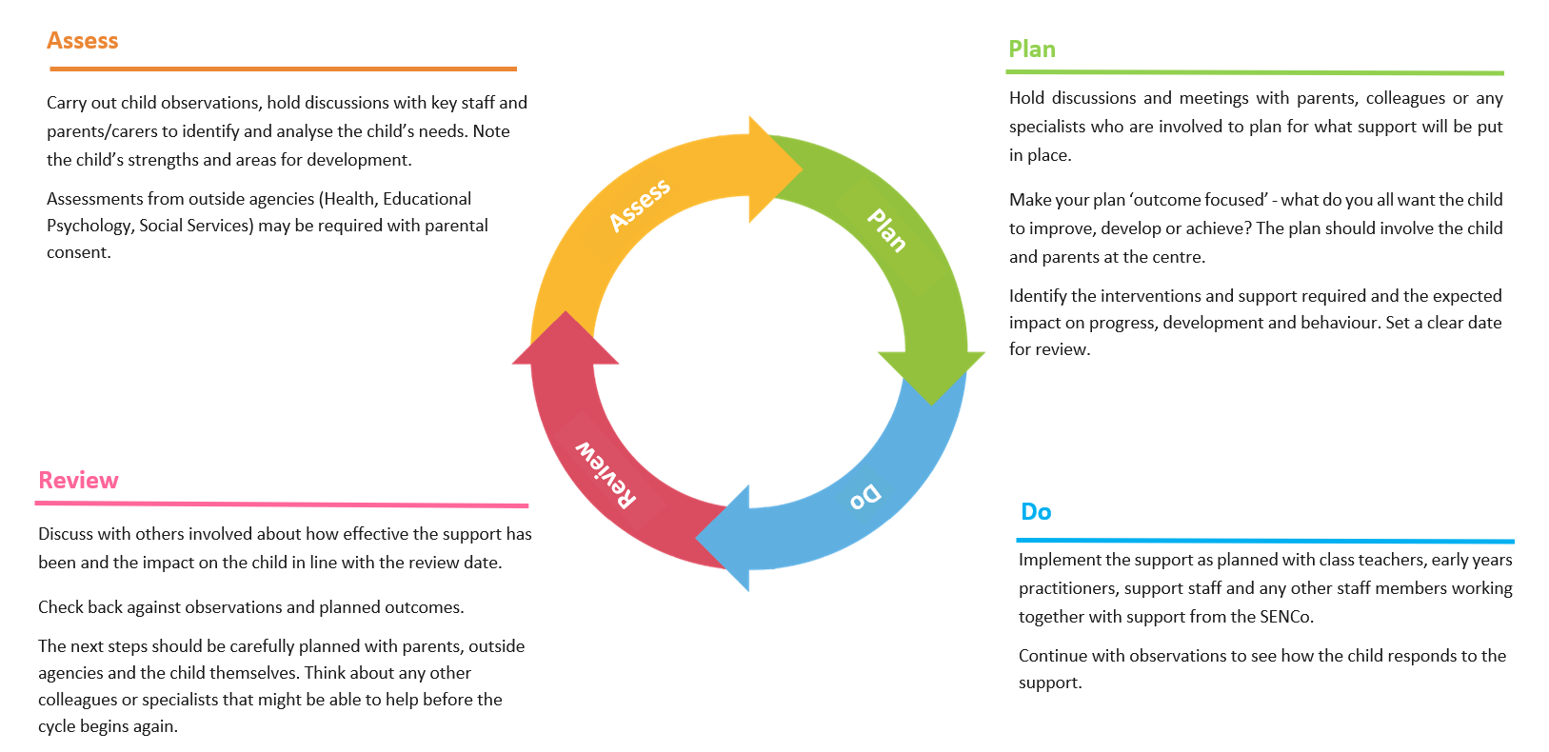

Examples of additional interventions and approaches for children with additional needs.

Teaching and Learning | Interventions
Quality first teaching.  Catch-Up teaching and learning.  Targeted interventions.  One to one support. | Individual speech and language programmes.  Reception language screening.  Colourful Semantics.  Word Agents.  Precision Monitoring.  Lexia.  Lego Therapy.  Learning Mentor (Individual programmes)  Handwriting/ fine motor skills.  Gross motor skills.
Outside Agency support | Children with additional needs will have:
School Health Team.  Education Psychology.  Speech Bubble, Speech and Language Service.  CAMHS (Child and Adolescent Mental Health Service.)  Bridgelea Outreach Support  Camberwell Park Outreach Support  RHOSEY Outreach Support  Big Manchester.  Counselling.  Barnardo’s.  Gadham Centre.  Child Services.  Early Help Services. | An individual profile including an individual Learning Plan.  Individual targets and identified interventions and support.  Termly reviews with teachers and SENCO/Assistant SENCO.  Termly reviews with parents.  Family centred approach to support.  Open door policy.

